**Third-party Link Custom Component**

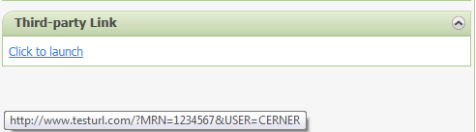

**Purpose**: Provide a custom component that creates a link to an external URL while providing patient MRN and the user name of the current user. This component must work on a Summary and Workflow views.

**Requirements**:

1. Create a CCL script that takes patient id and user id. Script will return the patient MRN and the user name of the current user.
2. The two different options created will include the following and be flexed by parameters passed to the CCL script:
   1. NONPROD – url will be <http://nonprod.testurl.com>.
   2. PROD – url will be <http://www.testurl.com>.
3. Create front-end javascript/css with displays a link.
4. Make sure to test on Summary and Workflow MPages

**Student Responsibilities**:

Student 1 🡺 Start creation of CCL script making sure to match the requirements above. Set-up everything BUT the query to pull data.

Student 2 🡺 Create query to pull data needed for component and test CCL script by itself

Student 3 🡺 Create custom component javascript such that it calls the CCL script created but only shows the JSON string in the component body.

Student 4 🡺 Setup a view in Bedrock which has one custom components labeled “Third-party Link.” Also create a tab in Prefmaint to show your newly created view.

Student 5 🡺 Update javascript code to display the link on the component. Component options will be created at this time as well.

Student 6 🡺 Fix stylesheet to display component per screenshot above. This should not require much.

Student 7 🡺 Test custom component on multiple patients, and with both options selected. Make sure all logic is sound.